*JSON iterate -* ***for Loop***

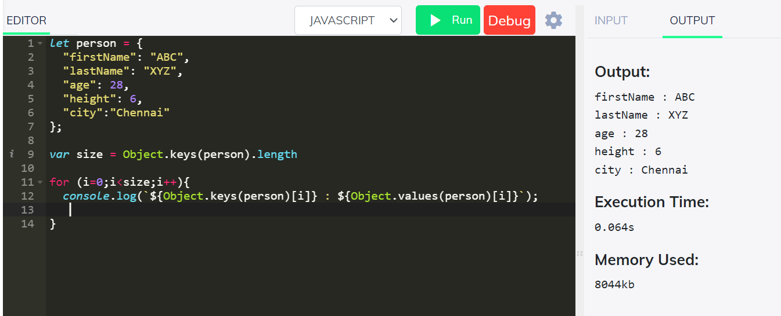

*JSON iterate -****for in Loop***

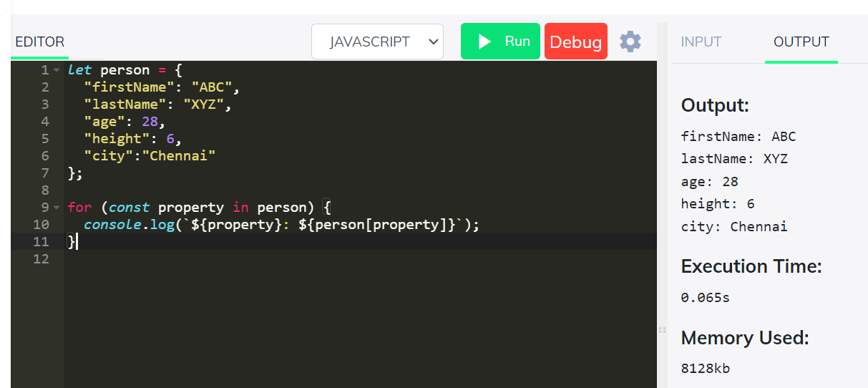

*JSON iterate -****for of Loop***

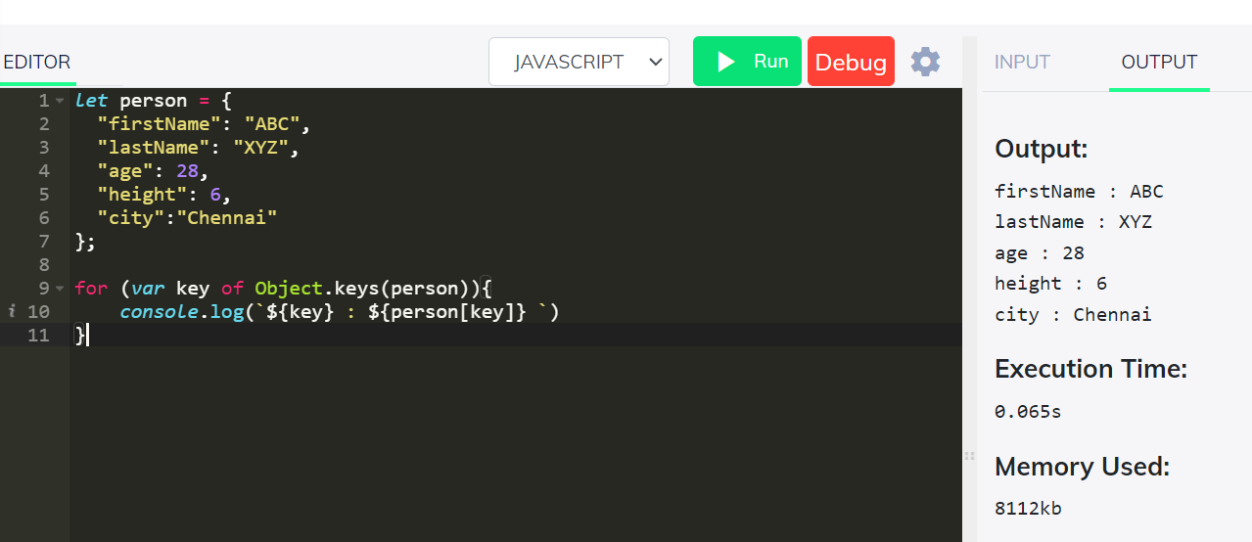

*JSON iterate -****forEach Loop***

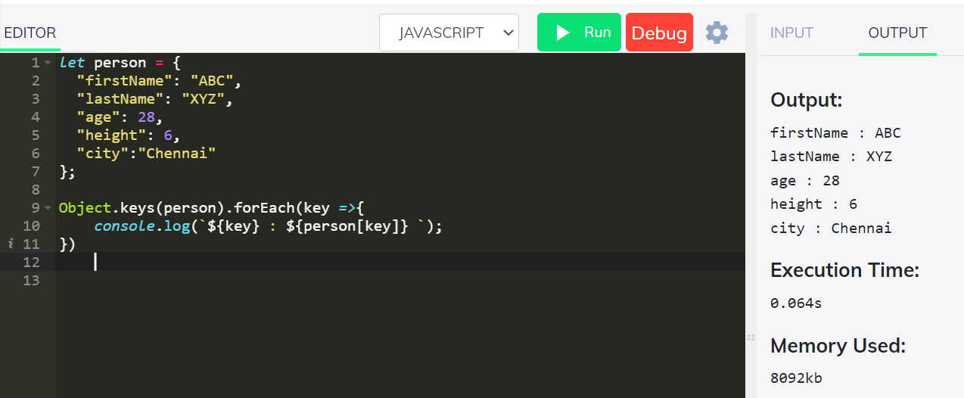

***Resume JSON Data:***

**Var Resume_Data = {**

**"Name": "Vegi Chandra Sekhar",**

**"Biodata": {**

**"address1": "D. No-39-26-35, Rajeev Nagar colony",**

**"address2":"Marripalem, Punjab hotel road",**

**"address3":"Andhra Pradesh, Viskahpatnam-530018",**

**"Phone_Number":"+91 9676431638",**

**"Email_Id":"chandrasekharvegi@gmail.com"**

**},**

**"Carrier_Objective":"To work with best of my abilities around a challenging environment that provides generous opportunities for learning that helps for my self-development as well as for the progress of my company.",**

**"Work_Experience":**

**{**

**"items":[**

**{**

**"Company":"Trimble Inc.",**

**"Designation" : "GIS Analyst – Trimble Maps (Oct’18 – Present)",**

**"Job Profile":"Creating and updating Trimble MAPS by Conflation data from various sources and validating them manually and further review by using Python and SQL queries in QGIS"**

**},**

**{**

**"Company":"Equalarcs Technologies Pvt Ltd.",**

**"Designation" : "GIS Engineer (Feb’18 – Aug’18)",**

**"Job Profile":"Digitization of cadastral maps and mapping land boundaries using DGPS field data, ETS data and satellite report preparation of Land Survey data for ULS (Urban Land Surveying), NOC (No Objection Certificate) based on FMBS (Field Measurement Book) and Rvm’s (RevenueVillage Maps) of Visakhapatnam District."**

**}**

**]**

**},**

**"Education":{**

**"degree": "Bachelor Of Technology",**

**"major": "Geo Informatics",**

**"Graduation Year":"2013- 2017)",**

**"CGPA":8.11,**

**"College":"Andhra University College of Engineering (A)",**

**"place":"Visakhapatnam, Andhra Pradesh, India"**

**},**

**"Skills":{**

**"Details":[**

**{**

**"Technical Skills":[**

**{**

**"type":"GIS Softwares",**

**"items": [**

**"Arc Gis Desktop",**

**"Qgis",**

**"Erdas Imagine",**

**"Postgresql",**

**"Autocad",**

**"Global Mapper"**

**]**

**},**

**{**

**"type":"Programming Languages",**

**"items":[**

**"Javascript",**

**"Python",**

**"c",**

**"SQL"**

**]**

**}**

**],**

**"Behavioural Skills":"Adaptable to the situation",**

**"Functional Skills" : "Team player"**

**}**

**]**

**},**

**"Projects":{**

**"items":[**

**{"type":"B. Tech project",**

**"details":[**

**{**

**"Place":"",**

**"Project_Title": "Spatial Integrated University Directory Search and Routing Mobile Application for Andhra University college of Engineering.",**

**"Timeline":"January 2017 – May 2017",**

**"Tools/ Technologies Language": [**

**"QGIS",**

**"Java",**

**"Android Studio",**

**"Eclipse",**

**"Postgresql"**

**],**

**"Description":[**

**"In this project ¸we designed a campus directory mobile application which integrates the list of staff, departments and, buildings with location data, for assisting the user to locate a university entity on the map based on directory search.",**

**"The application also traces the route from user input location to the desired location on the map to help the user navigate to the desired/searched attribute inside the campus within a short period of time."**

**]**

**}**

**]},**

**{"type":"Internship",**

**"details":[**

**{**

**"Place":"Regional Remote Sensing (west), ISRO, Jodhpur, Rajasthan, India",**

**"Project_Title": "Study on Land Use Dynamics in IGNP Canal Command Area Using Geospatial Techniques",**

**"Timeline":"May 2016 – July 2016",**

**"Tools/ Technologies Language": [**

**"QGIS",**

**"Erdas Imagine",**

**"Arc GIS"**

**],**

**"Description":[**

**"Performed Land Use/ Land Cover analysis for the command area of IGNP (Indira Gandhi Nahar Pariyojana) canal over the period 2004 – 2014 using IRS P6 AWiFS data.",**

**"Performed supervised and unsupervised classification to evaluate crop vigour in different parts of the command area during 2010 – 2015 using Landsat data and identified the change that has occurred in the command area over the years."**

**]**

**}**

**]}**

**]**

**}**

**}**

***Difference between window, screen and document in JavaScript.***

|  |  |  |
| --- | --- | --- |
| **WINDOW** | **SCREEN** | **DOCUMENT** |
| **Window** is the main JavaScript object root, i.e., the global object in a browser, and it can also be treated as the root of the document object model. You can access it as window.  **Window methods:**  ***window.open()***:  open a new window  ***window.close()***: close the current  window  ***window.moveTo()***: move the current window  ***window.resizeTo()***: resize the current window | Screen is a small information object about physical **screen dimensions**. It can be used to display screen width, height, colorDepth, pixelDepth etc. It is not mandatory to write **window prefix** with screen object. It can be written without window prefix.  **Properties:**  *screen.width*  *screen.height*  *screen.availWidth*  *screen.availHeight*  *screen.colorDepth*  *screen.pixelDepth* | The **Document object** represents any web page loaded in the browser and serves as an entry point into the web page’s content, which is the DOM tree. When an HTML document is loaded into a **web browser**, it becomes a document object. It is the root node of the HTML document. The document actually gets loaded inside the window object and has properties available to it like title, URL, cookie etc. |